Name:
______________________________
Signature:
______________________________
Date:
______________________________

Name:
______________________________
Signature:
______________________________
Date:
______________________________

Name:
______________________________
Signature:
______________________________
Date:
______________________________
St Joachim & St Anne
Catholic Parish
Swansea

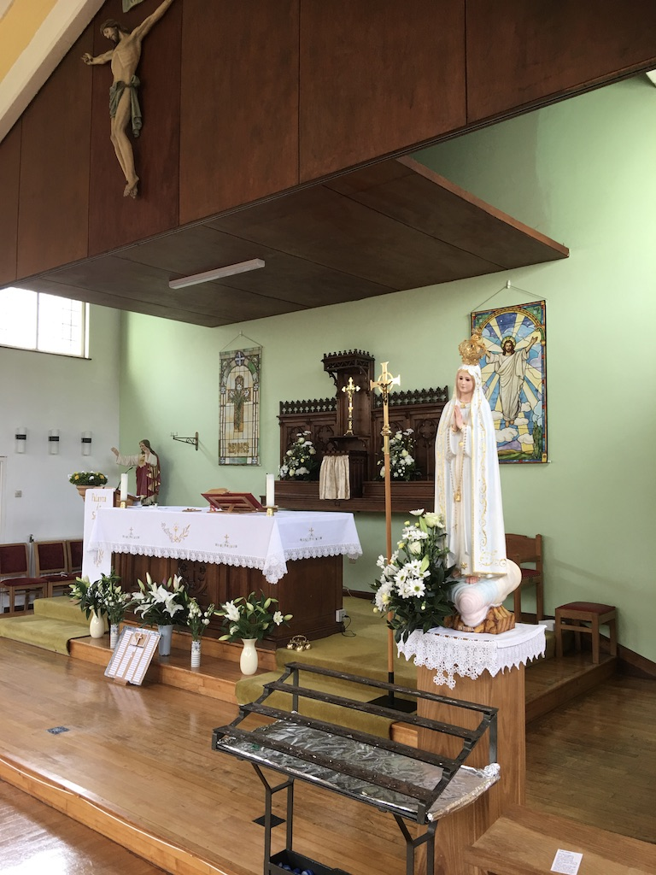

“GDPR” Compliant
Census Form
Household Address:

______________________________

______________________________

______________________________

Telephone:

______________________________

______________________________

Email:

______________________________

______________________________

Household Names:

In signing below, I agree to my personal details, as listed here, being kept indefinitely in a locked file, to be accessed only by the parish priest, when the need may arise to contact me.

Name:
______________________________
Signature:
______________________________
Date:
______________________________

Name:
______________________________
Signature:
______________________________
Date:
______________________________
P.t.o.

